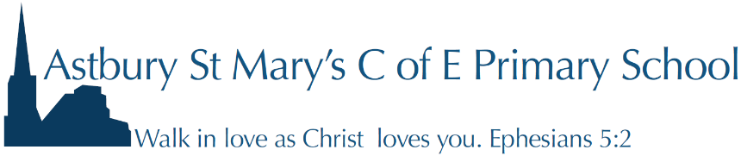
School Lane
Astbury
Cheshire
CW12 4RG
01260 272528
Head Teacher Miss P. Blythe
head@astbury.cheshire.sch.uk

29th May 2024

Dear Parents and carers

I am so pleased that you have chosen to come to Astbury St Mary’s and I am looking forward to welcoming you to the reception class and our Astbury family.

Mrs Armitt, the class teacher, is planning two come and play days 9 – 3:15pm:
- Thursday 27th June
- Friday 28th June

If your child is not already in Astbury Acorns Pre-School on these days, please give school a call or send an email to confirm that your child can come on these days. Your child is welcome to stay for all the day or just for a part of the day.

There will be a welcome to Astbury, starting reception, meeting for Parents and carers on Thursday 13th June at 7:00pm. Please do your best to try to attend this meeting. Mrs Armitt will make the presentation available if you are not able to attend.

School uniform is available from DPSportswear in Congleton. If you need any help with purchasing uniform, please be in touch as school has some good second hand items available.

The government currently provide free school lunches for all children in reception - Y2. These will need to be booked through the school online booking system Parentpay. Information about this will be given to you on your child’s first day. Snacks from Alison, the school cook, can also be booked and paid for using this system; alternatively, your child can bring their own healthy snack from home.

Your child will need a named water bottle which they will bring to school each day and PE kit which will stay in school in a PE bag.

For information about school please visit the following sites:

Our school webpage https://www.astburyschool.org.uk/ we have a starting reception tab.

For other information about what school is up to, you could follow our Facebook page. https://www.facebook.com/astburyschool/
There is also a wonderful PFA at Astbury and I hope that you would get on board with volunteering and supporting that group of staff and parents. They also have a Facebook group so please do have a look at the sorts of things they have done to raise money for the school.
https://www.facebook.com/groups/452544334952456/

Mrs Armitt and I will keep you updated with any information that you need. If there are any questions you have, please feel free to email Mrs Armitt, the class teacher or the school administrator, Miss Chapman.

aarmitt@astbury.cheshire.sch.uk or admin@astbury.cheshire.sch.uk.

Yours faithfully

Miss Blythe
Head teacher

