Power Maths calculation policy, KS1
The following pages show the Power Maths progression in calculation (addition, subtraction, multiplication and division) and how this works in line with the National Curriculum. The consistent use of the CPA (concrete, pictorial, abstract) approach across Power Maths helps children develop mastery across all the operations in an efficient and reliable way. This policy shows how these methods develop children’s confidence in their understanding of both written and mental methods.
KEY STAGE 1
Children develop the core ideas that underpin all calculation. They begin by connecting calculation with counting on and counting back, but they should learn that understanding wholes and parts will enable them to calculate efficiently and accurately, and with greater flexibility. They learn how to use an understanding of 10s and 1s to develop their calculation strategies, especially in addition and subtraction.
Key language: whole, part, ones, ten, tens, number bond, add, addition, plus, total, altogether, subtract, subtraction, find the difference, take away, minus, less, more, group, share, equal, equals, is equal to, groups, equal groups, times, multiply, multiplied by, divide, share, shared equally, times-table
Addition and subtraction: Children first learn to connect addition and subtraction with counting, but they soon develop two very important skills: an understanding of parts and wholes, and an understanding of unitising 10s, to develop efficient and effective calculation strategies based on known number bonds and an increasing awareness of place value. Addition and subtraction are taught in a way that is interlinked to highlight the link between the two operations.  A key idea is that children will select methods and approaches based on their number sense. For example, in Year 1, when faced with 15 − 3 and 15 − 13, they will adapt their ways of approaching the calculation appropriately. The teaching should always emphasise the importance of mathematical thinking to ensure accuracy and flexibility of approach, and the importance of using known number facts to harness their recall of bonds within 20 to support both addition and subtraction methods.  In Year 2, they will start to see calculations presented in a column format, although this is not expected to be formalised until KS2. We show the column method in Year 2 as an option; teachers may not wish to include it until Year 3. |  | Multiplication and division: Children develop an awareness of equal groups and link this with counting in equal steps, starting with 2s, 5s and 10s. In Year 2, they learn to connect the language of equal groups with the mathematical symbols for multiplication and division.  They learn how multiplication and division can be related to repeated addition and repeated subtraction to find the answer to the calculation.  In this key stage, it is vital that children explore and experience a variety of strong images and manipulative representations of equal groups, including concrete experiences as well as abstract calculations.  Children begin to recall some key multiplication facts, including doubles, and an understanding of the 2, 5 and 10 times-tables and how they are related to counting. |  | Fractions: In Year 1, children encounter halves and quarters, and link this with their understanding of sharing. They experience key spatial representations of these fractions, and learn to recognise examples and non-examples, based on their awareness of equal parts of a whole.  In Year 2, they develop an awareness of unit fractions and experience non-unit fractions, and they learn to write them and read them in the common format of numerator and denominator.
Year 1
 | Concrete |  | Pictorial |  | Abstract
Year 1  Addition | Counting and adding more  Children add one more person or object to a group to find one more. |  | Counting and adding more  Children add one more cube or counter to a group to represent one more.  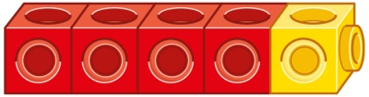  One more than 4 is 5. |  | Counting and adding more  Use a number line to understand how to link counting on with finding one more.  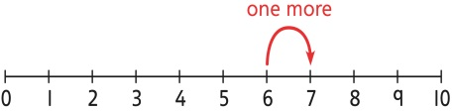  One more than 6 is 7.  7 is one more than 6.  Learn to link counting on with adding more than one.  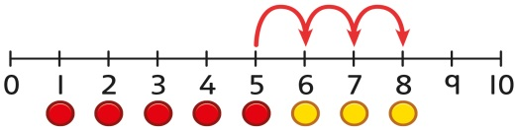  5 + 3 = 8
 | Understanding part-part-whole relationship  Sort people and objects into parts and understand the relationship with the whole.  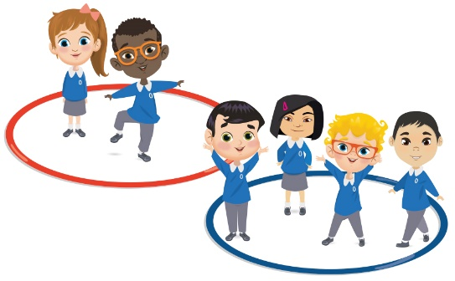  The parts are 2 and 4. The whole is 6. |  | Understanding part-part-whole relationship  Children draw to represent the parts and understand the relationship with the whole.  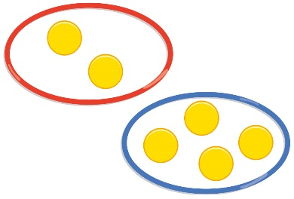  The parts are 1 and 5. The whole is 6. |  | Understanding part-part-whole relationship  Use a part-whole model to represent the numbers.  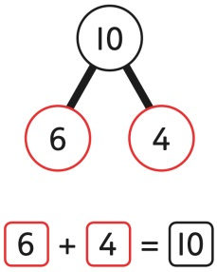  6 + 4 = 10
 | Knowing and finding number bonds within 10  Break apart a group and put back together to find and form number bonds.  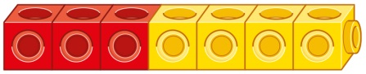  3 + 4 = 7  6 = 2 + 4 |  | Knowing and finding number bonds within 10  Use five and ten frames to represent key number bonds.  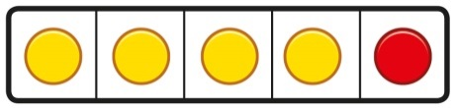  5 = 4 + 1  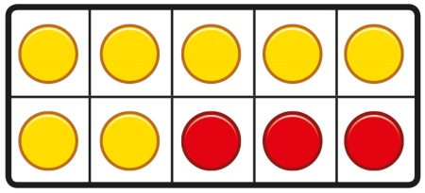  10 = 7 + 3 |  | Knowing and finding number bonds within 10  Use a part-whole model alongside other representations to find number bonds. Make sure to include examples where one of the parts is zero.  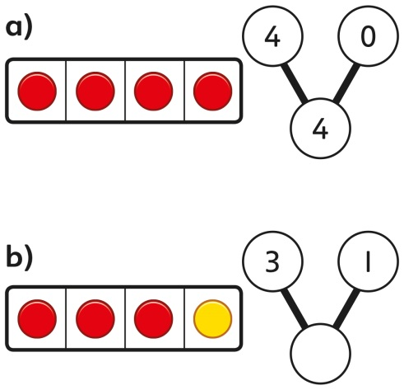  4 + 0 = 4  3 + 1 = 4
 | Understanding teen numbers as a complete 10 and some more  Complete a group of 10 objects and count more.  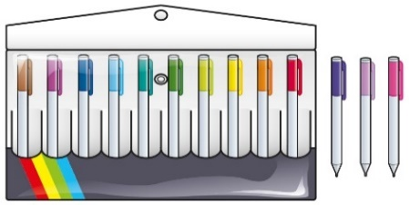  13 is 10 and 3 more. |  | Understanding teen numbers as a complete 10 and some more  Use a ten frame to support understanding of a complete 10 for teen numbers.  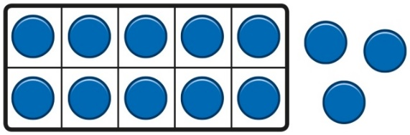  13 is 10 and 3 more. |  | Understanding teen numbers as a complete 10 and some more.  1 ten and 3 ones equal 13.  10 + 3 = 13
 | Adding by counting on  Children use knowledge of counting to 20 to find a total by counting on using people or objects.  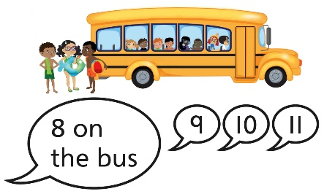 |  | Adding by counting on  Children use counters to support and represent their counting on strategy.  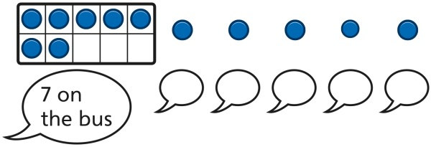 |  | Adding by counting on  Children use number lines or number tracks to support their counting on strategy.  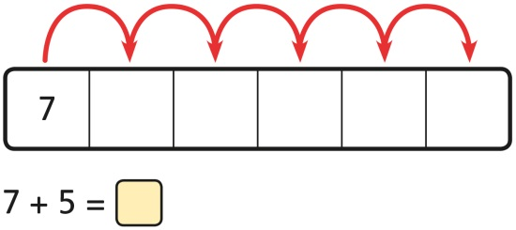
 | Adding the 1s  Children use bead strings to recognise how to add the 1s to find the total efficiently.  2 + 3 = 5  12 + 3 = 15 |  | Adding the 1s  Children represent calculations using ten frames to add a teen and 1s.  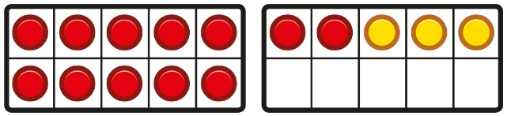  2 + 3 = 5  12 + 3 = 15 |  | Adding the 1s  Children recognise that a teen is made from a 10 and some 1s and use their knowledge of addition within 10 to work efficiently.  3 + 5 = 8  So, 13 + 5 = 18
 | Bridging the 10 using number bonds  Children use a bead string to complete a 10 and understand how this relates to the addition.  7 add 3 makes 10.  So, 7 add 5 is 10 and 2 more. |  | Bridging the 10 using number bonds  Children use counters to complete a ten frame and understand how they can add using knowledge of number bonds to 10.  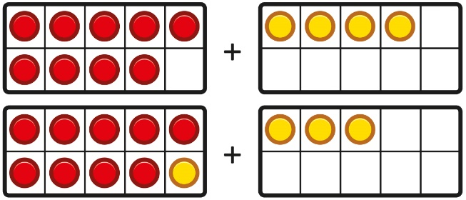  . |  | Bridging the 10 using number bonds  Use a part-whole model and a number line to support the calculation.  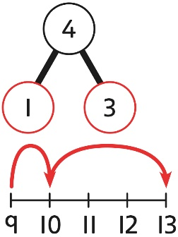  9 + 4 = 13
Year 1  Subtraction | Counting back and taking away  Children arrange objects and remove to find how many are left.  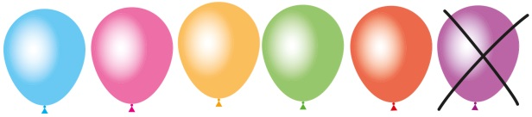  1 less than 6 is 5.  6 subtract 1 is 5. |  | Counting back and taking away  Children draw and cross out or use counters to represent objects from a problem.  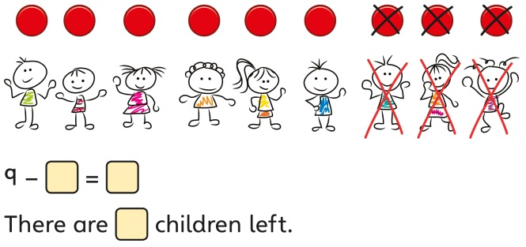 |  | Counting back and taking away  Children count back to take away and use a number line or number track to support the method.  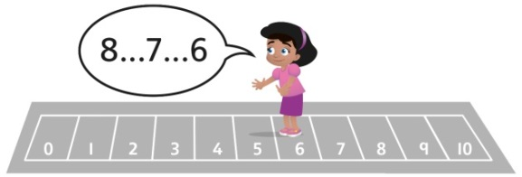  9 − 3 = 6
 | Finding a missing part, given a whole and a part  Children separate a whole into parts and understand how one part can be found by subtraction.  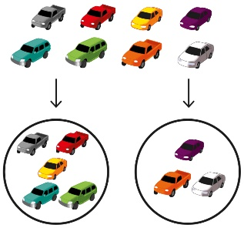  8 − 5 = ? |  | Finding a missing part, given a whole and a part  Children represent a whole and a part and understand how to find the missing part by subtraction.  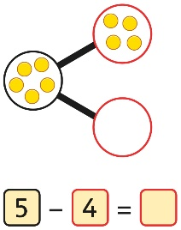 |  | Finding a missing part, given a whole and a part  Children use a part-whole model to support the subtraction to find a missing part.  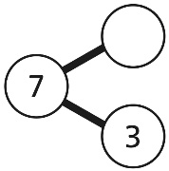  7 − 3 = ?  Children develop an understanding of the relationship between addition and subtraction facts in a part-whole model.  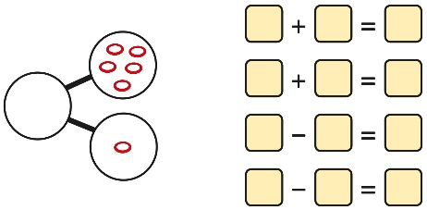
 | Finding the difference  Arrange two groups so that the difference between the groups can be worked out.  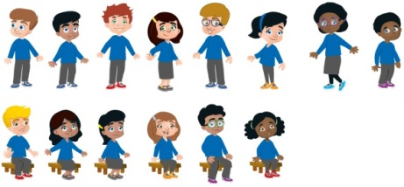  8 is 2 more than 6.  6 is 2 less than 8.  The difference between 8 and 6 is 2. |  | Finding the difference  Represent objects using sketches or counters to support finding the difference.  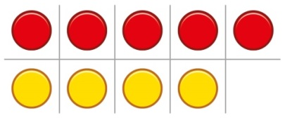  5 − 4 = 1  The difference between 5 and 4 is 1. |  | Finding the difference  Children understand ‘find the difference’ as subtraction.  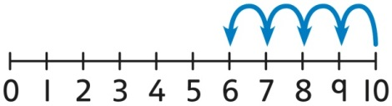  10 − 4 = 6  The difference between 10 and 6 is 4.
 | Subtraction within 20  Understand when and how to subtract 1s efficiently.  Use a bead string to subtract 1s efficiently.  5 − 3 = 2  15 − 3 = 12 |  | Subtraction within 20  Understand when and how to subtract 1s efficiently.  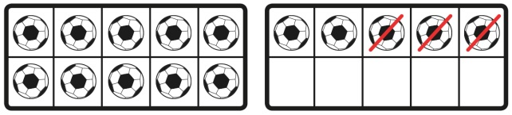  5 − 3 = 2  15 − 3 = 12 |  | Subtraction within 20  Understand how to use knowledge of bonds within 10 to subtract efficiently.  5 − 3 = 2  15 − 3 = 12
 | Subtracting 10s and 1s  For example: 18 − 12  Subtract 12 by first subtracting the 10, then the remaining 2.  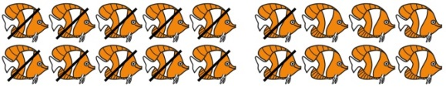  First subtract the 10, then take away 2. |  | Subtracting 10s and 1s  For example: 18 − 12  Use ten frames to represent the efficient method of subtracting 12.  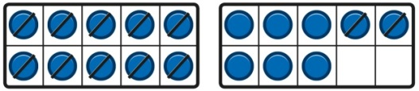  First subtract the 10, then subtract 2. |  | Subtracting 10s and 1s  Use a part-whole model to support the calculation.  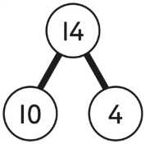  19 − 14  19 − 10 = 9  9 − 4 = 5  So, 19 − 14 = 5
 | Subtraction bridging 10 using number bonds  For example: 12 − 7  Arrange objects into a 10 and some 1s, then decide on how to split the 7 into parts.  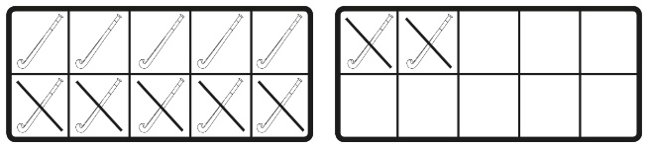  7 is 2 and 5, so I take away the 2 and  then the 5. |  | Subtraction bridging 10 using number bonds  Represent the use of bonds using ten frames.  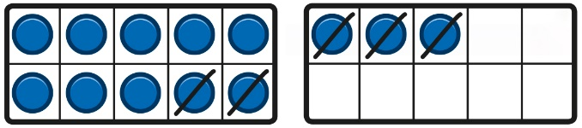  For 13 – 5, I take away 3 to make 10, then take away 2 to make 8. |  | Subtraction bridging 10 using number bonds  Use a number line and a part-whole model to support the method.  13 − 5  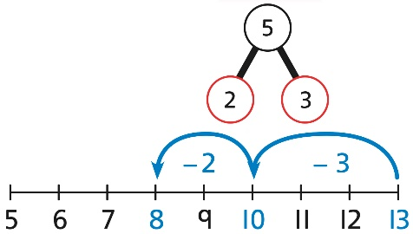
Year 1  Multiplication | Recognising and making equal groups  Children arrange objects in equal and unequal groups and understand how to recognise whether they are equal.  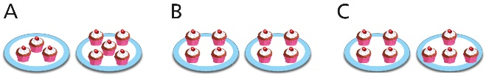 |  | Recognising and making equal groups  Children draw and represent equal and unequal groups.  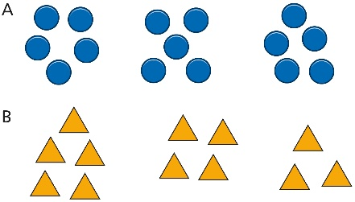 |  | Describe equal groups using words  Three equal groups of 4.  Four equal groups of 3.
 | Finding the total of equal groups by counting in 2s, 5s and 10s  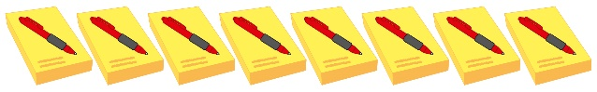  There are 5 pens in each pack …  5…10…15…20…25…30…35…40… |  | Finding the total of equal groups by counting in 2s, 5s and 10s  100 squares and ten frames support counting in 2s, 5s and 10s.  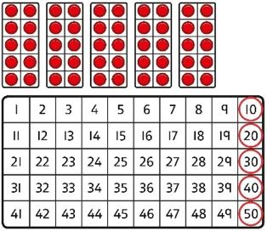 |  | Finding the total of equal groups by counting in 2s, 5s and 10s  Use a number line to support repeated addition through counting in 2s, 5s and 10s.  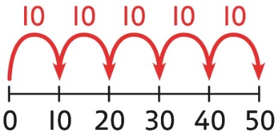
Year 1  Division | Grouping  Learn to make equal groups from a whole and find how many equal groups of a certain size can be made.  Sort a whole set people and objects into equal groups.  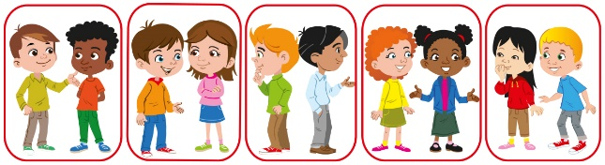  There are 10 children altogether.  There are 2 in each group.  There are 5 groups. |  | Grouping  Represent a whole and work out how many equal groups.  There are 10 in total.  There are 5 in each group.  There are 2 groups. |  | Grouping  Children may relate this to counting back in steps of 2, 5 or 10.  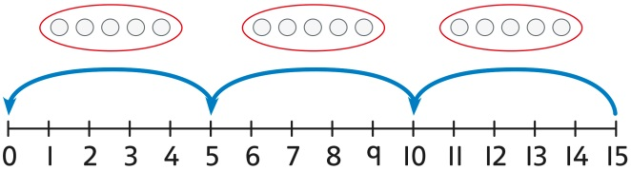
 | Sharing  Share a set of objects into equal parts and work out how many are in each part.  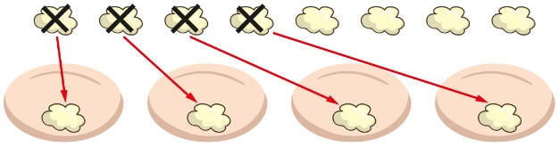 |  | Sharing  Sketch or draw to represent sharing into equal parts. This may be related to fractions.  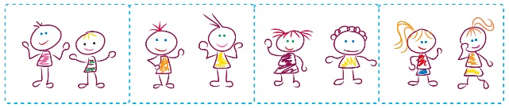 |  | Sharing  10 shared into 2 equal groups gives 5 in each group.

Year 2
 | Concrete | Pictorial | Abstract
Year 2
Addition
Understanding 10s and 1s | Group objects into 10s and 1s.  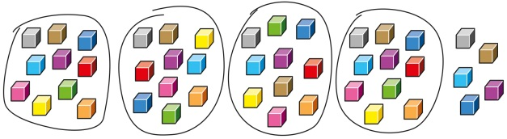  Bundle straws to understand unitising of 10s.  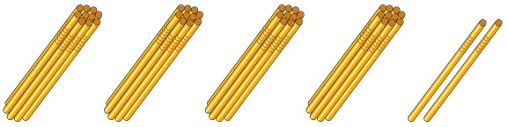 | Understand 10s and 1s equipment, and link with visual representations on ten frames.  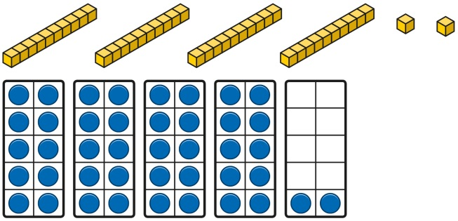 | Represent numbers on a place value grid, using equipment or numerals.  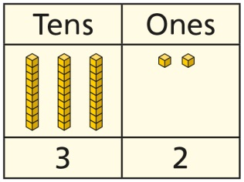  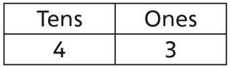
Adding 10s | Use known bonds and unitising to add 10s.  I know that 4 + 3 = 7.  So, I know that 4 tens add 3 tens is 7 tens. | Use known bonds and unitising to add 10s.  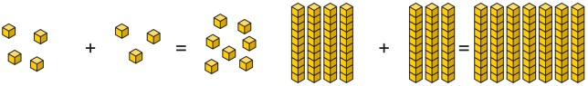  I know that 4 + 3 = 7.  So, I know that 4 tens add 3 tens is 7 tens. | Use known bonds and unitising to add 10s.  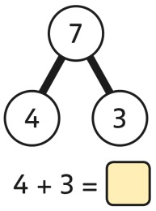  4 + 3 = 7  4 tens + 3 tens = 7 tens  40 + 30 = 70
Adding a  1-digit number to a 2-digit number not bridging a 10 | Add the 1s to find the total. Use known bonds within 10.  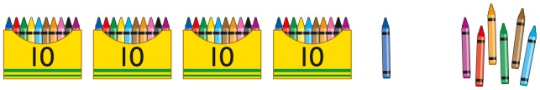  41 is 4 tens and 1 one.  41 add 6 ones is 4 tens and 7 ones.  This can also be done in a place value grid.  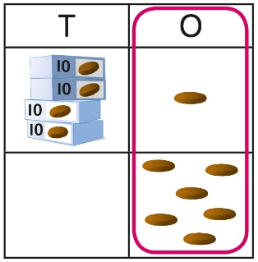 | Add the 1s.  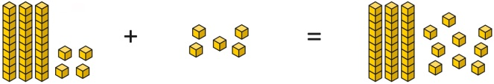  34 is 3 tens and 4 ones.  4 ones and 5 ones are 9 ones.  The total is 3 tens and 9 ones.  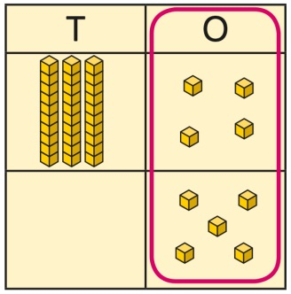 | Add the 1s.  Understand the link between counting on and using known number facts. Children should be encouraged to use known number bonds to improve efficiency and accuracy.  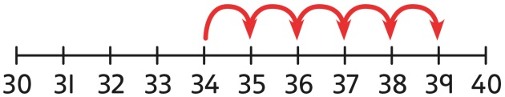  This can be represented horizontally or vertically.  34 + 5 = 39  or  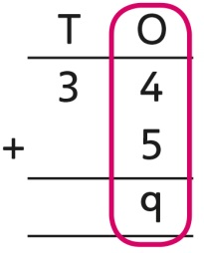
Adding a  1-digit number to a 2-digit number bridging 10 | Complete a 10 using number bonds.  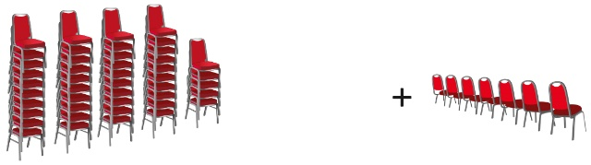  There are 4 tens and 5 ones.  I need to add 7. I will use 5 to complete a 10, then add 2 more. | Complete a 10 using number bonds.  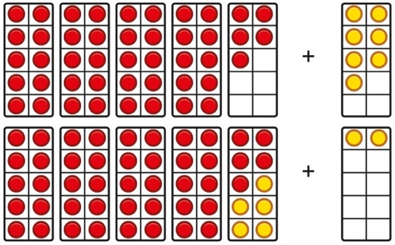 | Complete a 10 using number bonds.  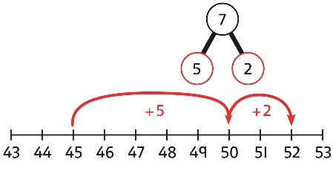  7 = 5 + 2  45 + 5 + 2 = 52
Adding a  1-digit number to a 2-digit number using exchange | Exchange 10 ones for 1 ten.  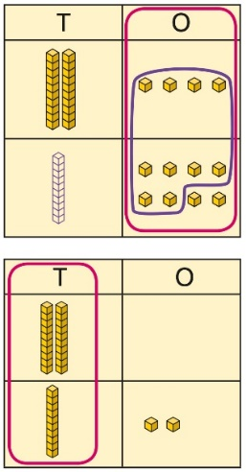 | Exchange 10 ones for 1 ten.  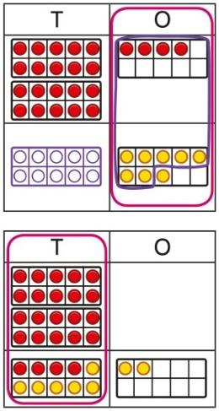 | Exchange 10 ones for 1 ten.  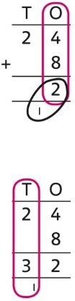
Adding a multiple of 10 to a 2-digit number | Add the 10s and then recombine.  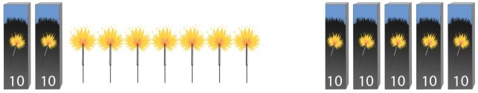  27 is 2 tens and 7 ones.  50 is 5 tens.  There are 7 tens in total and 7 ones.  So, 27 + 50 is 7 tens and 7 ones. | Add the 10s and then recombine.  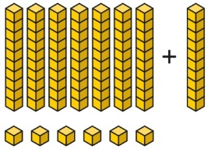  66 is 6 tens and 6 ones.  66 + 10 = 76  A 100 square can support this understanding.  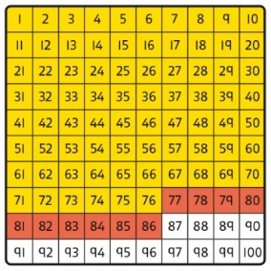 | Add the 10s and then recombine.  37 + 20 = ?  30 + 20 = 50  50 + 7 = 57  37 + 20 = 57
Adding a multiple of 10 to a 2-digit number using columns | Add the 10s using a place value grid to support.  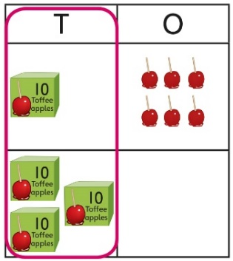  16 is 1 ten and 6 ones.  30 is 3 tens.  There are 4 tens and 6 ones in total. | Add the 10s using a place value grid to support.  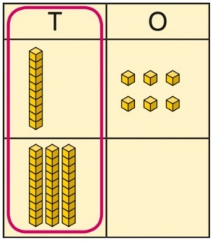  16 is 1 ten and 6 ones.  30 is 3 tens.  There are 4 tens and 6 ones in total. | Add the 10s represented vertically. Children must understand how the method relates to unitising of 10s and place value.  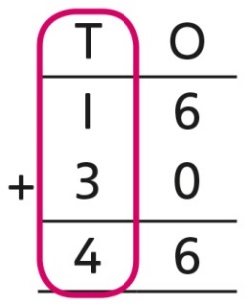  1 + 3 = 4  1 ten + 3 tens = 4 tens  16 + 30 = 46
Adding two  2-digit numbers | Add the 10s and 1s separately.  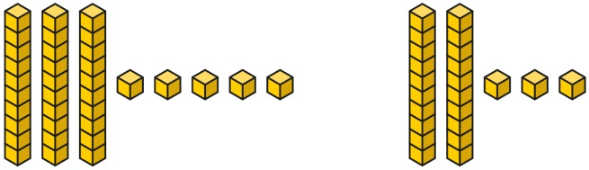  5 + 3 = 8  There are 8 ones in total.  3 + 2 = 5  There are 5 tens in total.  35 + 23 = 58 | Add the 10s and 1s separately. Use a  part-whole model to support.  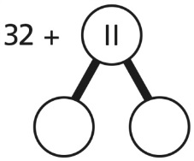  11 = 10 + 1  32 + 10 = 42  42 + 1 = 43  32 + 11 = 43 | Add the 10s and the 1s separately, bridging 10s where required. A number line can support the calculations.  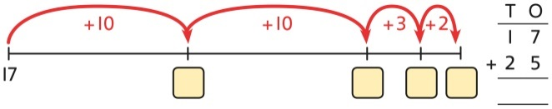  17 + 25
Adding two  2-digit numbers using a place value grid | Add the 1s. Then add the 10s.  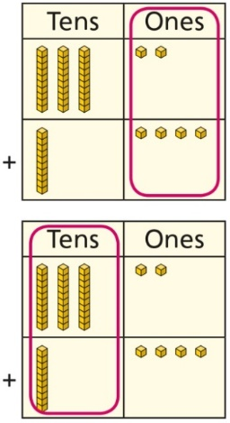 |  | Add the 1s. Then add the 10s.  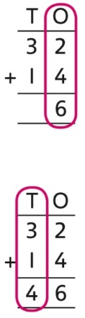
Adding two  2-digit numbers with exchange | Add the 1s. Exchange 10 ones for a ten. Then add the 10s.  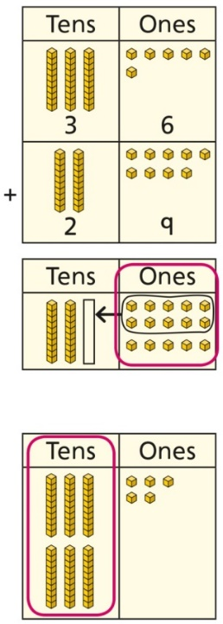 |  | Add the 1s. Exchange 10 ones for a ten. Then add the 10s.  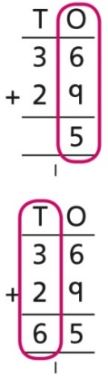
Year 2
Subtraction
Subtracting multiples of 10 | Use known number bonds and unitising to subtract multiples of 10.  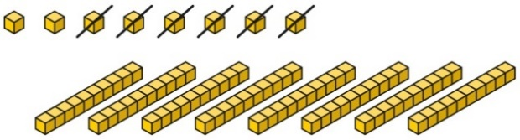  8 subtract 6 is 2.  So, 8 tens subtract 6 tens is 2 tens. | Use known number bonds and unitising to subtract multiples of 10.  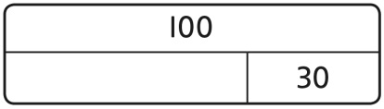  10 − 3 = 7  So, 10 tens subtract 3 tens is 7 tens. | Use known number bonds and unitising to subtract multiples of 10.  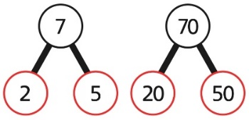  7 tens subtract 5 tens is 2 tens.  70 − 50 = 20
Subtracting a single-digit number | Subtract the 1s. This may be done in or out of a place value grid.  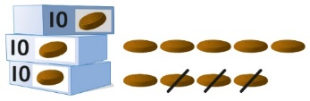  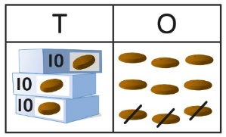 | Subtract the 1s. This may be done in or out of a place value grid.  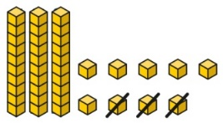  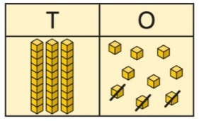 | Subtract the 1s. Understand the link between counting back and subtracting the 1s using known bonds.  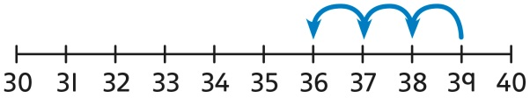  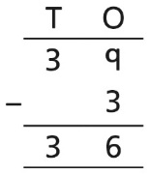 9 − 3 = 6  39 − 3 = 36
Subtracting a single-digit number bridging 10 | Bridge 10 by using known bonds.  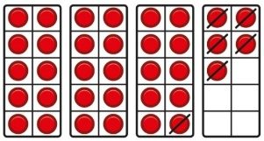  35 − 6  I took away 5 counters, then 1 more. | Bridge 10 by using known bonds.  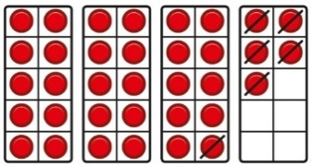  35 − 6  First, I will subtract 5, then 1. | Bridge 10 by using known bonds.  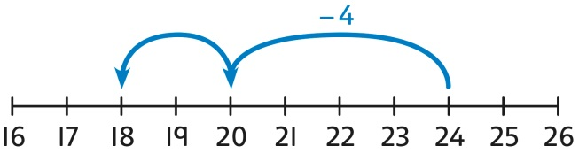  24 − 6 = ?  24 − 4 − 2 = ?
Subtracting a single-digit number using exchange | Exchange 1 ten for 10 ones. This may be done in or out of a place value grid.  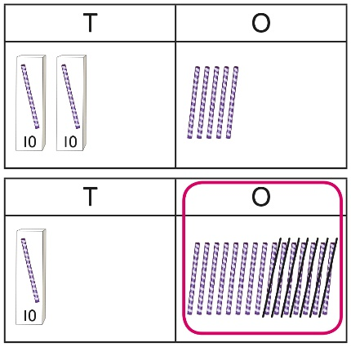 | Exchange 1 ten for 10 ones.  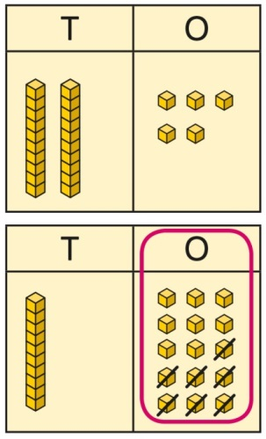 | Exchange 1 ten for 10 ones.  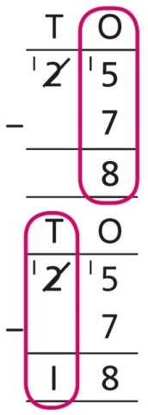  25 − 7 = 18
Subtracting a  2-digit number | Subtract by taking away.  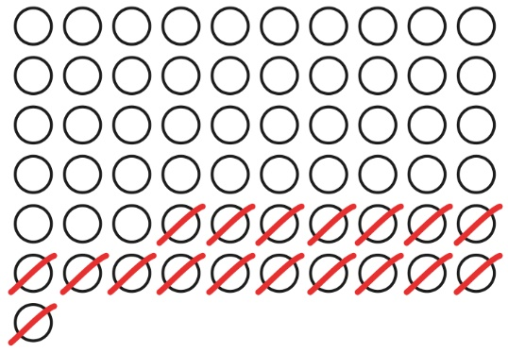  61 − 18  I took away 1 ten and 8 ones. | Subtract the 10s and the 1s.  This can be represented on a 100 square.  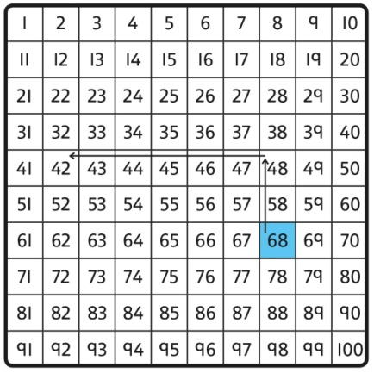 | Subtract the 10s and the 1s.  This can be represented on a number line.  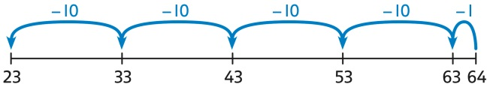  64 − 41 = ?  64 − 1 = 63  63 − 40 = 23  64 − 41 = 23  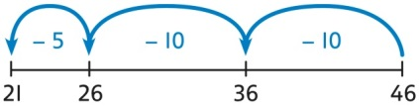  46 − 20 = 26  26 − 5 = 21  46 − 25 = 21
Subtracting a  2-digit number using place value and columns | Subtract the 1s. Then subtract the 10s. This may be done in or out of a place value grid.  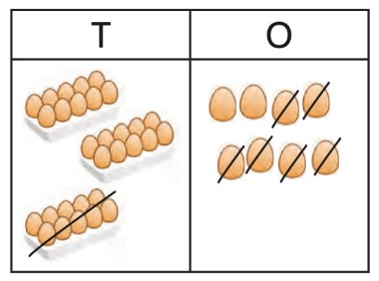  38 − 16 = 22 | Subtract the 1s. Then subtract the 10s.  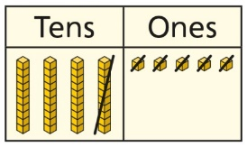 | Using column subtraction, subtract the 1s. Then subtract the 10s.  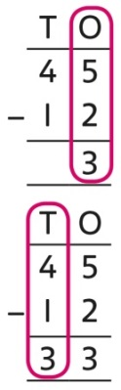
Subtracting a  2-digit number with exchange |  | Exchange 1 ten for 10 ones. Then subtract the 1s. Then subtract the 10s.  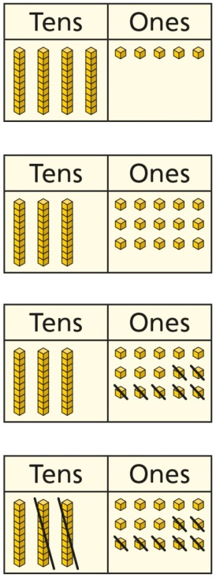 | Using column subtraction, exchange 1 ten for 10 ones. Then subtract the 1s. Then subtract the 10s.  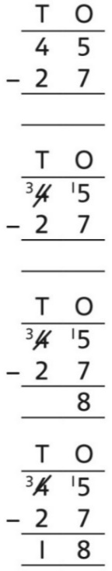
Year 2
Multiplication
Equal groups and repeated addition | Recognise equal groups and write as repeated addition and as multiplication.  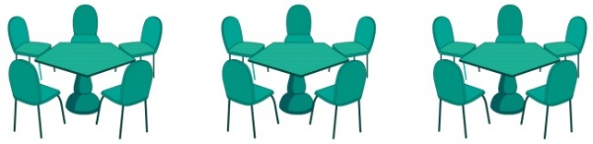  3 groups of 5 chairs  15 chairs altogether | Recognise equal groups using standard objects such as counters and write as repeated addition and multiplication.  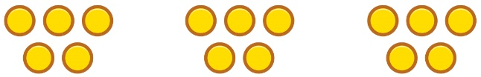  3 groups of 5  15 in total | Use a number line and write as repeated addition and as multiplication.  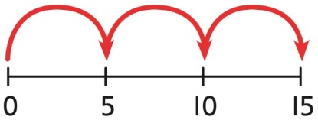  5 + 5 + 5 = 15  3 × 5 = 15
Using arrays to represent multiplication and support understanding | Understand the relationship between arrays, multiplication and repeated addition.  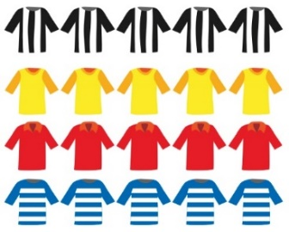  4 groups of 5 | Understand the relationship between arrays, multiplication and repeated addition.  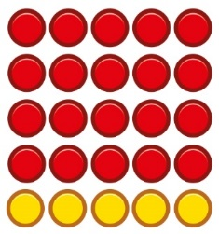  4 groups of 5 … 5 groups of 5 | Understand the relationship between arrays, multiplication and repeated addition.  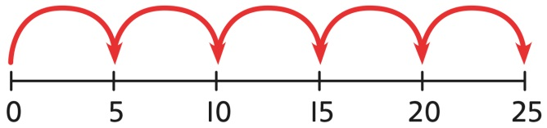  5 × 5 = 25
Understanding commutativity | Use arrays to visualise commutativity.  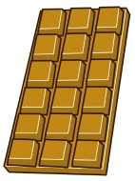  I can see 6 groups of 3.  I can see 3 groups of 6. | Form arrays using counters to visualise commutativity. Rotate the array to show that orientation does not change the multiplication.  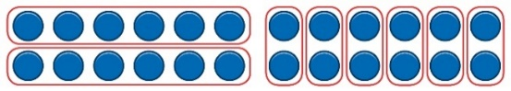  This is 2 groups of 6 and also 6 groups of 2. | Use arrays to visualise commutativity.  4 + 4 + 4 + 4 + 4 = 20  5 + 5 + 5 + 5 = 20  4 × 5 = 20 and 5 × 4 = 20
Learning ×2, ×5 and ×10 table facts | Develop an understanding of how to unitise groups of 2, 5 and 10 and learn corresponding times-table facts.  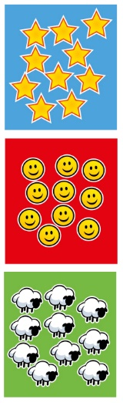  3 groups of 10 … 10, 20, 30  3 × 10 = 30 | Understand how to relate counting in unitised groups and repeated addition with knowing key times-table facts.  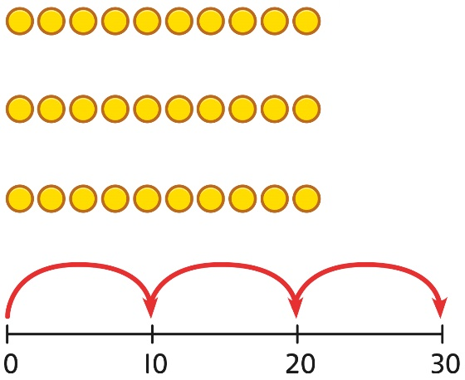  10 + 10 + 10 = 30  3 × 10 = 30 | Understand how the times-tables increase and contain patterns.  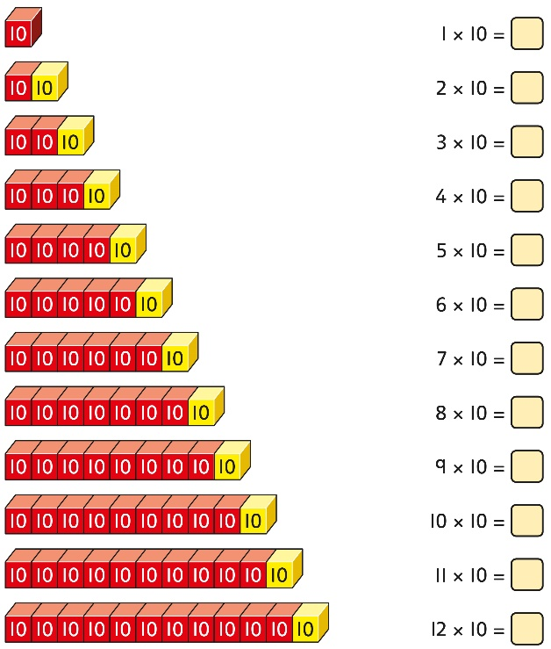  5 × 10 = 50  6 × 10 = 60
Year 2
Division
Sharing equally | Start with a whole and share into equal parts, one at a time.  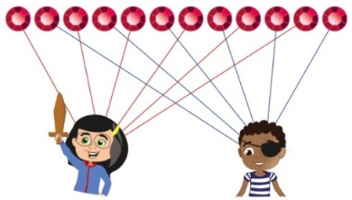  12 shared equally between 2.  They get 6 each.  Start to understand how this also relates to grouping. To share equally between 3 people, take a group of 3 and give 1 to each person. Keep going until all the objects have been shared  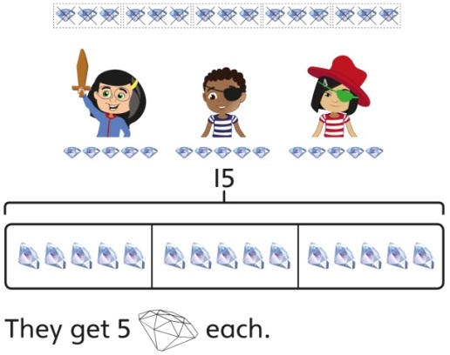  15 shared equally between 3.  They get 5 each. | Represent the objects shared into equal parts using a bar model.  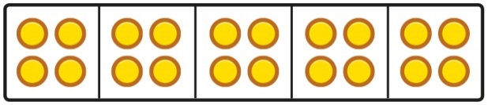  20 shared into 5 equal parts.  There are 4 in each part. | Use a bar model to support understanding of the division.  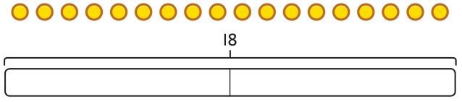  18 ÷ 2 = 9
Grouping equally | Understand how to make equal groups from a whole.  8 divided into 4 equal groups.  There are 2 in each group. | Understand the relationship between grouping and the division statements.  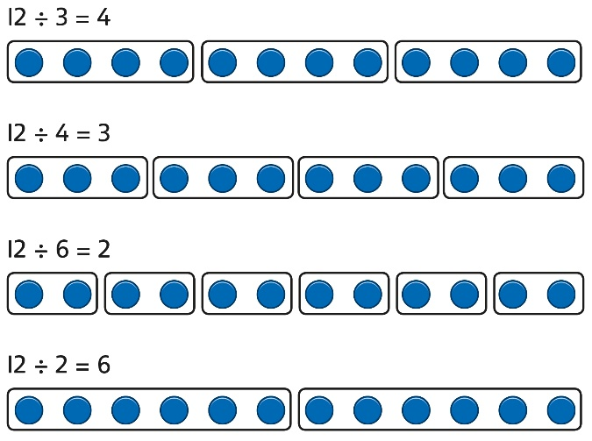 | Understand how to relate division by grouping to repeated subtraction.  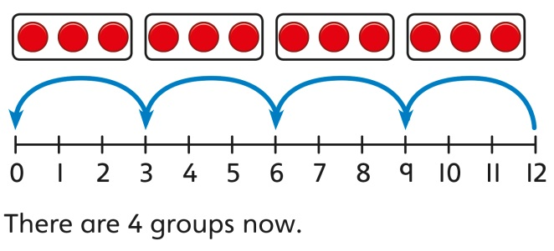  12 divided into groups of 3.  12 ÷ 3 = 4  There are 4 groups.
Using known times-tables to solve divisions | Understand the relationship between multiplication facts and division.  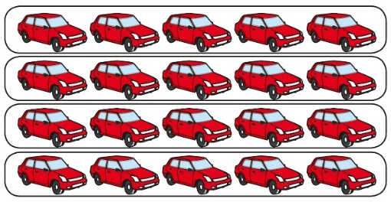  4 groups of 5 cars is 20 cars in total.  20 divided by 4 is 5. | Link equal grouping with repeated subtraction and known times-table facts to support division.  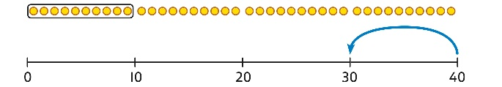  40 divided by 4 is 10.  Use a bar model to support understanding of the link between times-table knowledge and division.  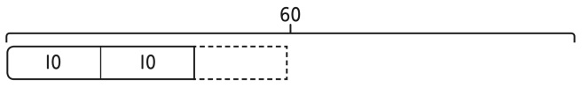 | Relate times-table knowledge directly to division.  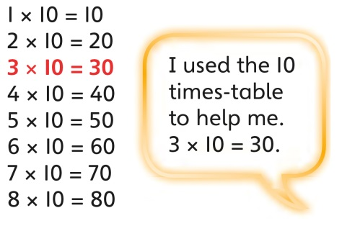  I know that 3 groups of 10 makes 30, so I know that 30 divided by 10 is 3.  3 × 10 = 30 so 30 ÷ 10 = 3

